**STUDY OF LEAD AND PESTICIDES ACCUMULATION IN THE BONES OF EURASIAN OTTERS IN THE UNITED KINGDOM USING PYTHON 3.9.14**

**Course: Data science and machine learning for the biosciences**

**Anusha Mohan Kumar (2350551), University of the West of England**

INTRODUCTION

The study was conducted from 1992 to 2004 to quantify the contaminants accumulated in the bones of Eurasian otters in Wales and England region. The contaminants identified were lead, organochloride pesticides such as dieldrin, Dichlorodiphenyldichloroethylene (dde), Polychlorinated biphenyls (PCBs) and hexachlorobenzene (hcbenz). The biological characteristics of otters were recorded along with the place and year of the samples taken. The aim is to study whether the variation in contaminant accumulation reflects individual variation in otters and temporal variation.

METHOD

The dataset has multiple dependent variables (various contaminants), so for better visualization, the organochloride compounds were grouped as total pesticides. The variation in lead and pesticide accumulation was visualized using individual, spatial and temporal variables.

The principal component analysis explains the relationship between variables and captures most of the variance in the data by reducing the dimensionality. PCA was carried out to find if different organochloride pesticides were correlated.

All the statistical analysis was carried out using Python 3.9.14. modules pandas, researchpy and sklearn modules, for graphical visualization seaborn and matplotlib modules were used.

RESULTS

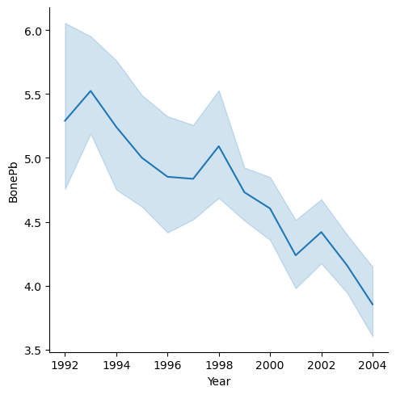The mean lead accumulation in male and female otters are 4.51 ± 0.06 and 4.71 ± 0.09 ug/kg, respectively. The mean bone Pb in female adults and young ones did not vary, whereas the subadult and juvenile males accumulated more lead than the adult male. The lead content in the bones of the otters gradually declined over the years.

Figure 1 : Temporal change of lead content in the bones of the otters

The first principal component (PC1) explains 53% of the variation in the pesticide data, the second principal component (PC2) explains 16% and together nearly 70%.

Each variable's importance is measured by the magnitude of the values in every component which is obtained by the code pca.components_ . Variables 4 to 12 (PCB 105 - PCB 187) are important for PC1 and variables 1,2,3 and 13 (dieldrin, dde,tde and hcbenz) for PC2, thus indicating a correlation between variables.

Figure 2: Magnitude of each variable contributing to the principal component

CONCLUSION

Individual variation in age and sex of the otters had no influence on the contaminant’s accumulation in the bones of the otters. Nearly 98% of the variation was explained by 10 principal components. From the above analysis, we can highlight the versatility of the principal component analysis which can study the correlation of variables not only on independent variables but also on dependent variables which is organo-chloride compounds in this study.

GITHUB LINK

<https://github.com/Anusha-Mohan-Kumar/SWBio-Data-Science---Individual-project>